**Database Comparison PostgreSQL**

**Features**

1. Compare 2 databases of different connections.
2. Compare 2 schemas and all schemas.
3. Compare 2 tables and all tables.
4. Compare 2 paired columns.

**Technologies used for code development:** HTML, CSS, PHP, JavaScript, PostgreSQL

**Technologies you need**

This project is specifically for comparing PostgreSQL databases. To run this project, you will need a server that can run PHP code and a browser to view the pages.

**How to run the project**

1. To choose databases of different connections, go to config.php and config2.php and add the two different connections.
2. Next, go to the browser and type localhost/database_comparison_postgresql/select_db.php

**To view All Schemas**

1. Select Databases and click “All Schemas”.

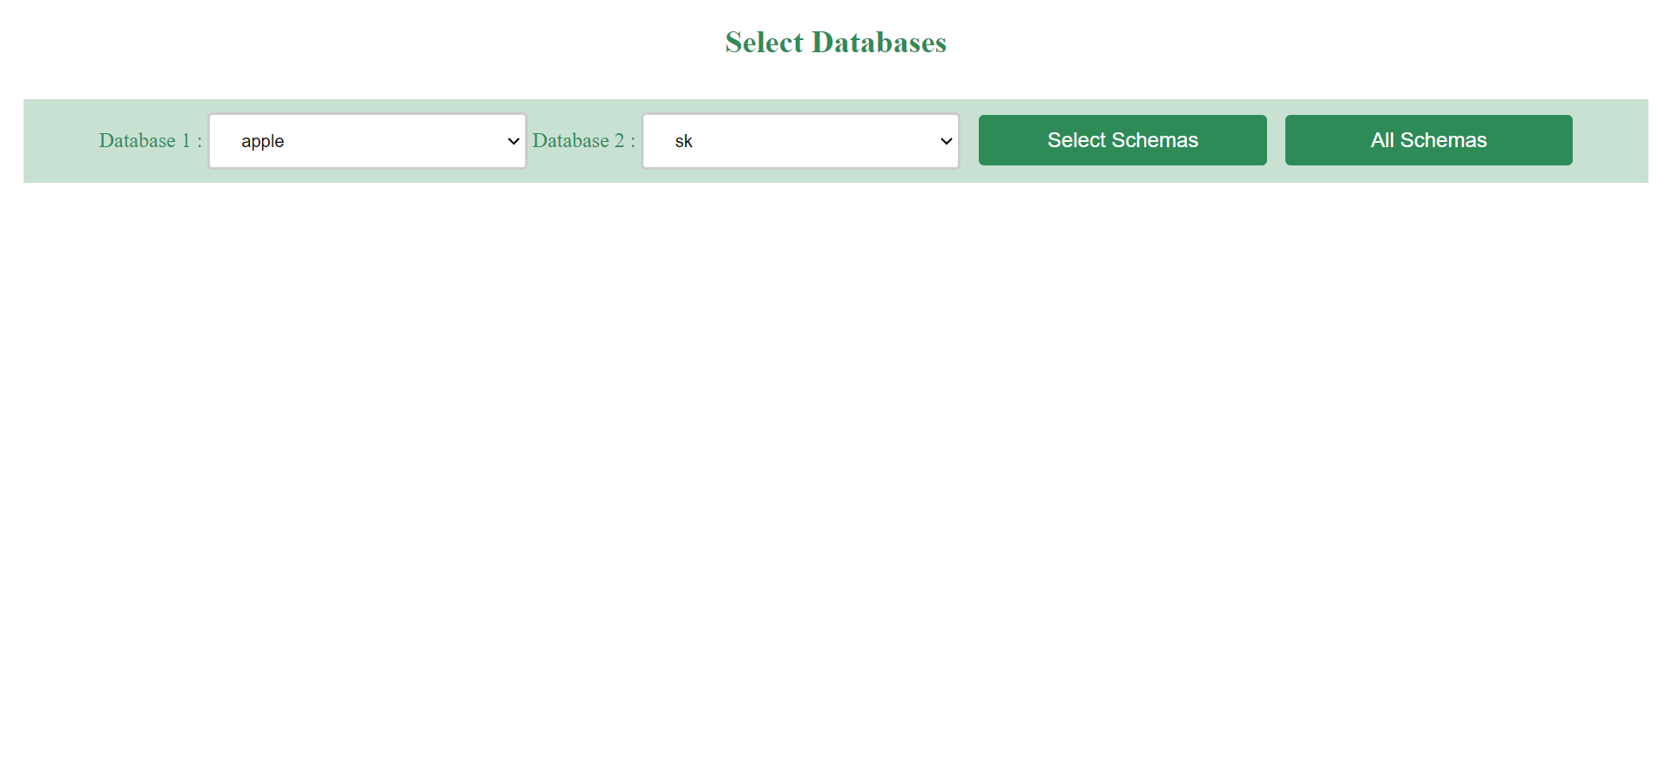

1. View “Matching Schemas”, “Non-Matching Schemas”, “Common Schema, Different Tables” and “Common Schema, Common Table, Different Columns”.

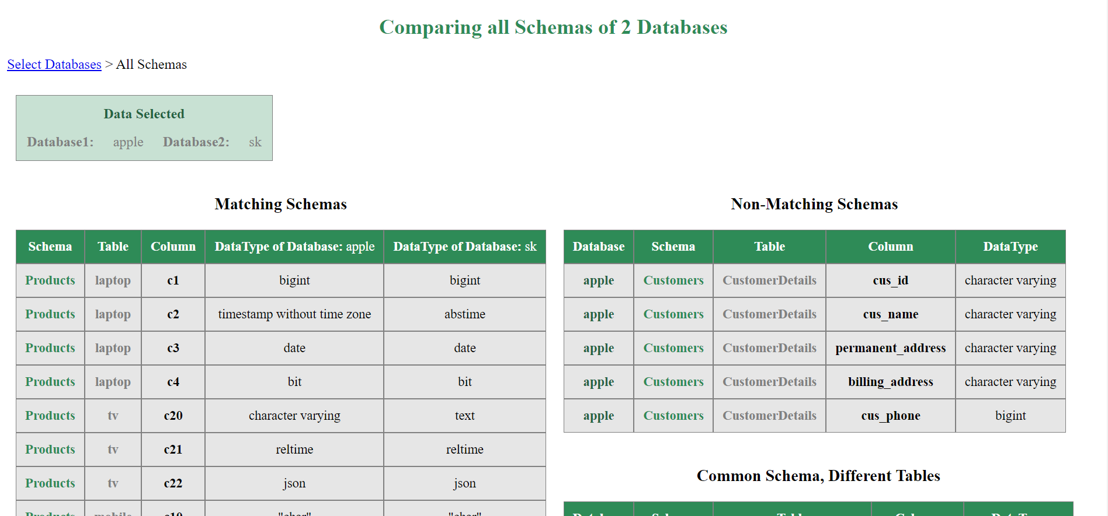

Matching Schemas

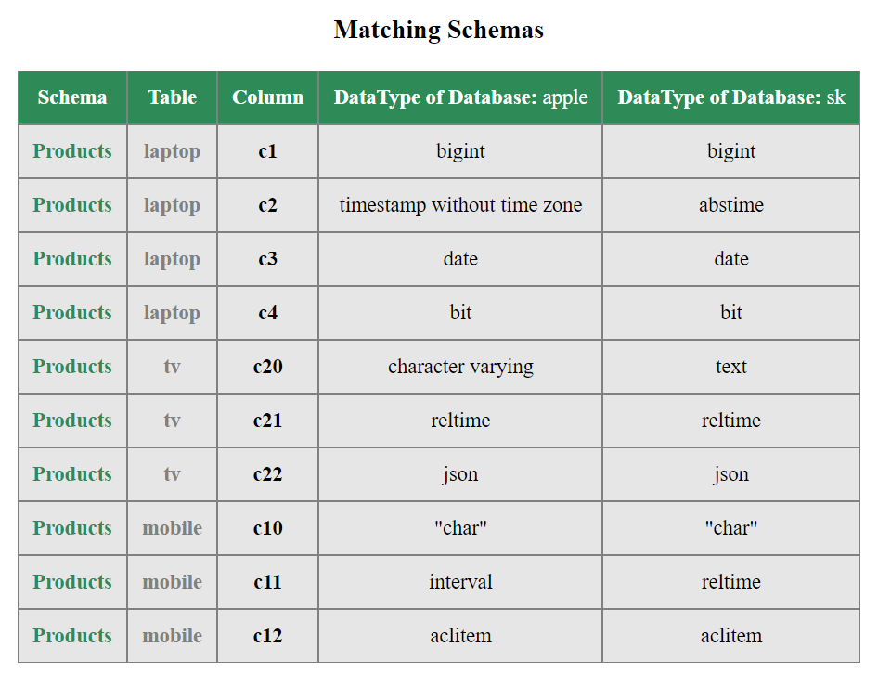

Non-Matching Schemas

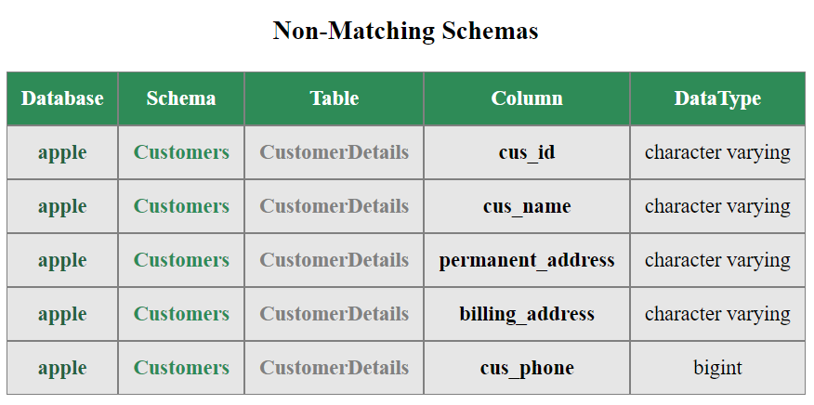

Common Schema, Different Tables

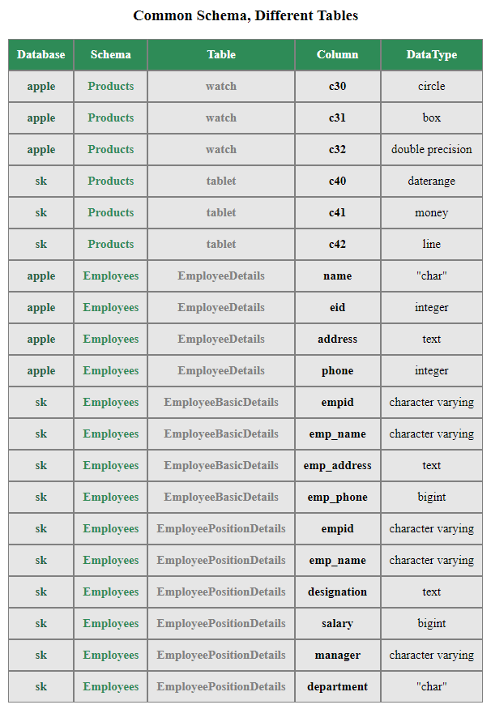

Common Schema, Common Table, Different Columns

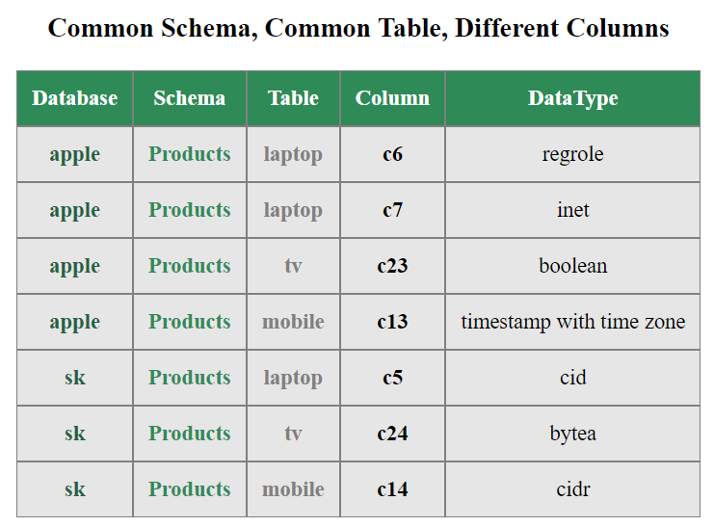

**To view All Tables**

1. Select Databases and click “Select Schemas”.

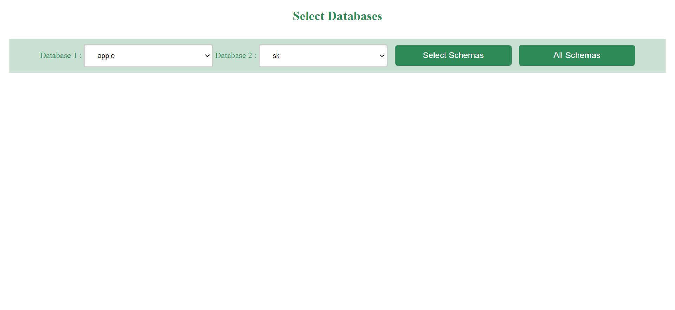

1. Select Schemas and click “All Tables”.

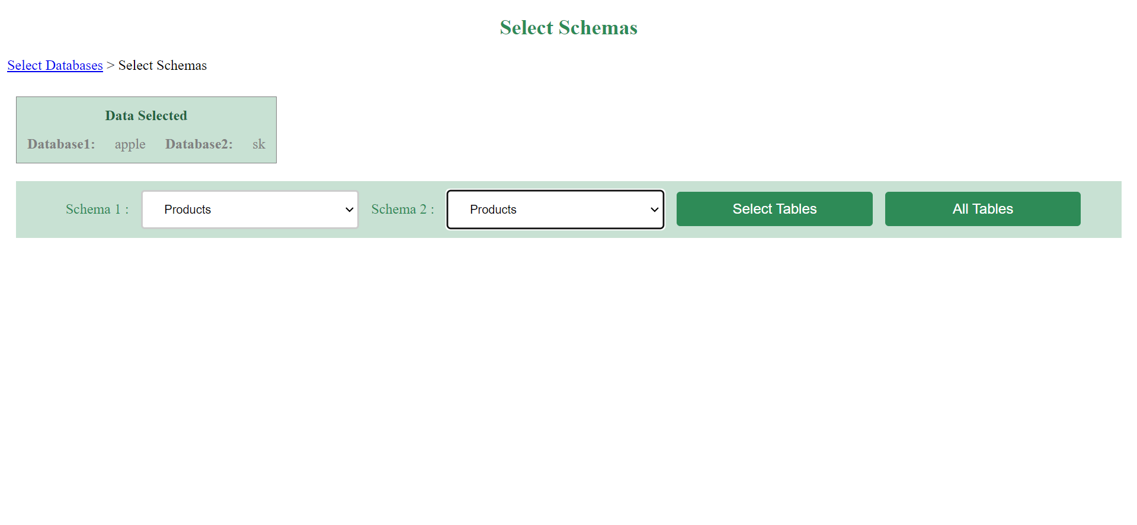

1. View the matching and non-matching tables and columns of the two databases.

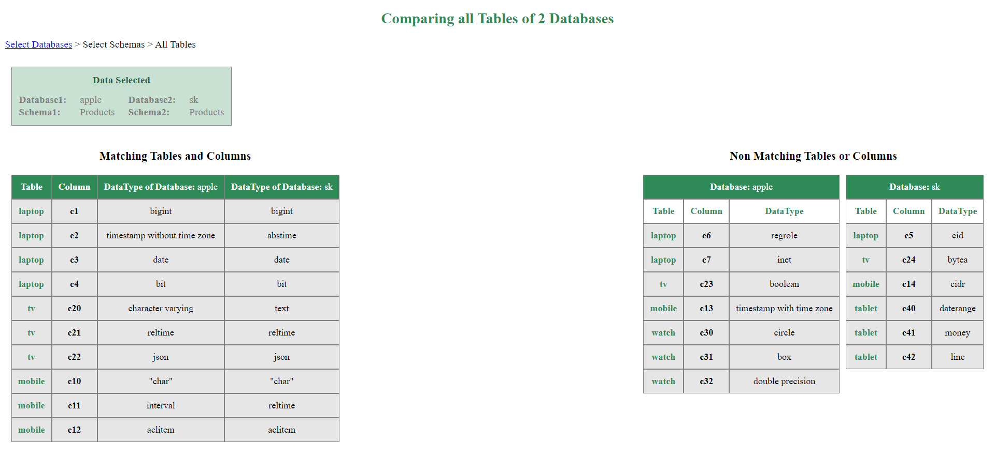

**To view Two Tables**

1. Select Databases and click “Select Schemas”.



2. Select Schemas and click “Select Tables”.



3. Select Tables and click “Two Tables”.

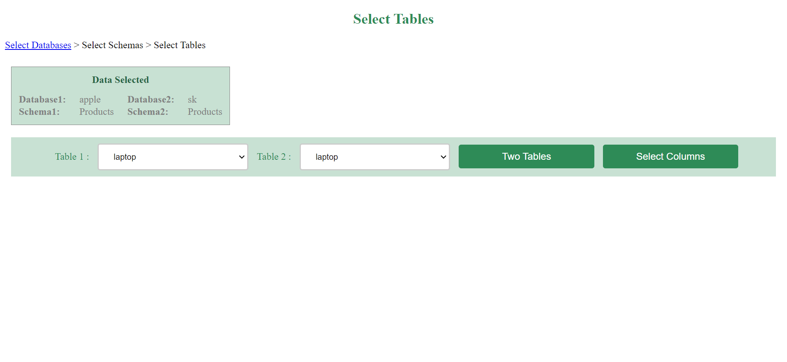

4. View matching and non-matching columns of the selected two tables.

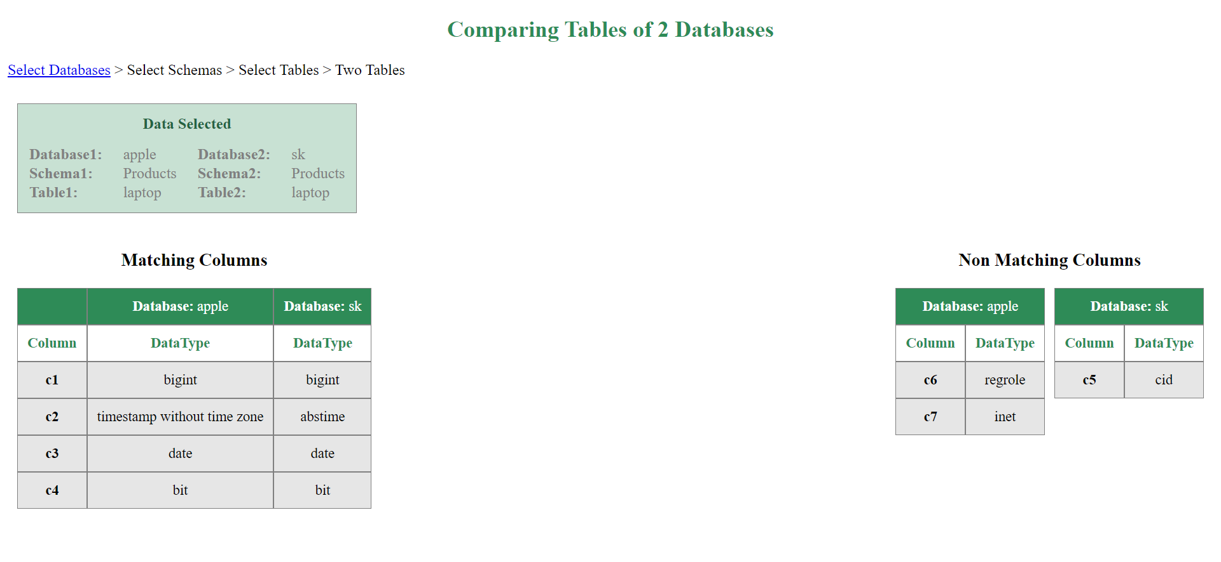

**To view Paired Columns**

Use this to compare paired columns like tcm_key, tcm_value; tet_email_code, tet_email_template.

1. Select Databases and click “Select Schemas”.

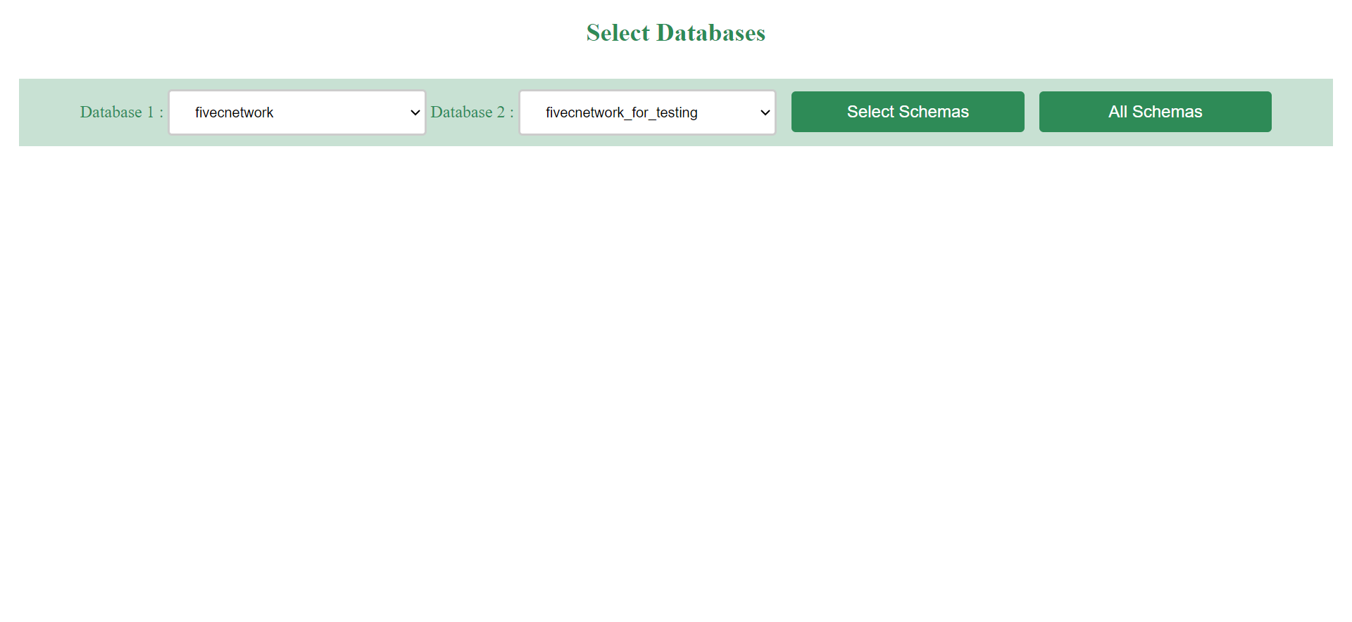

1. Select Schemas and click “Select Tables”.

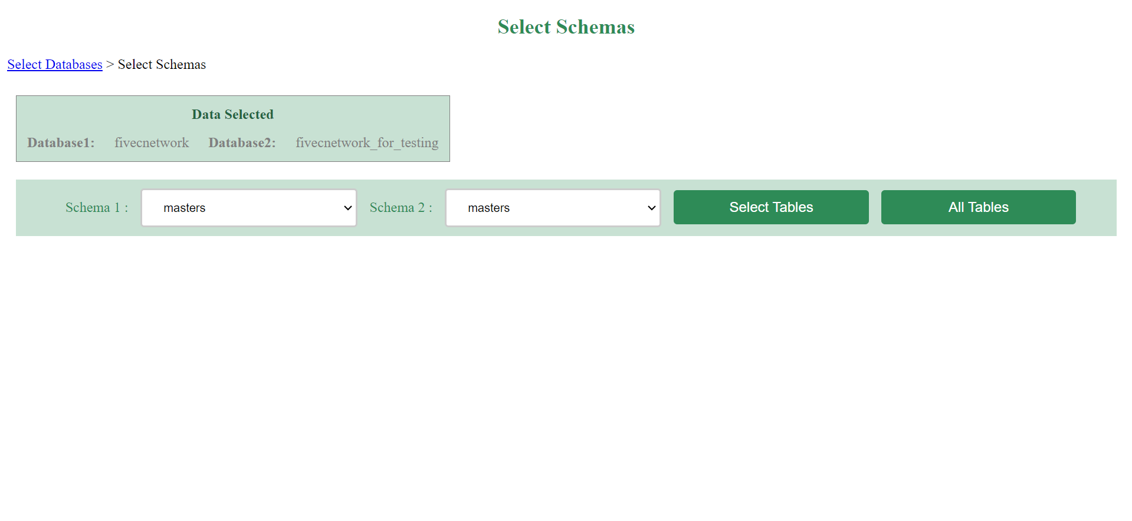

1. Select Tables and click “Select Columns”.

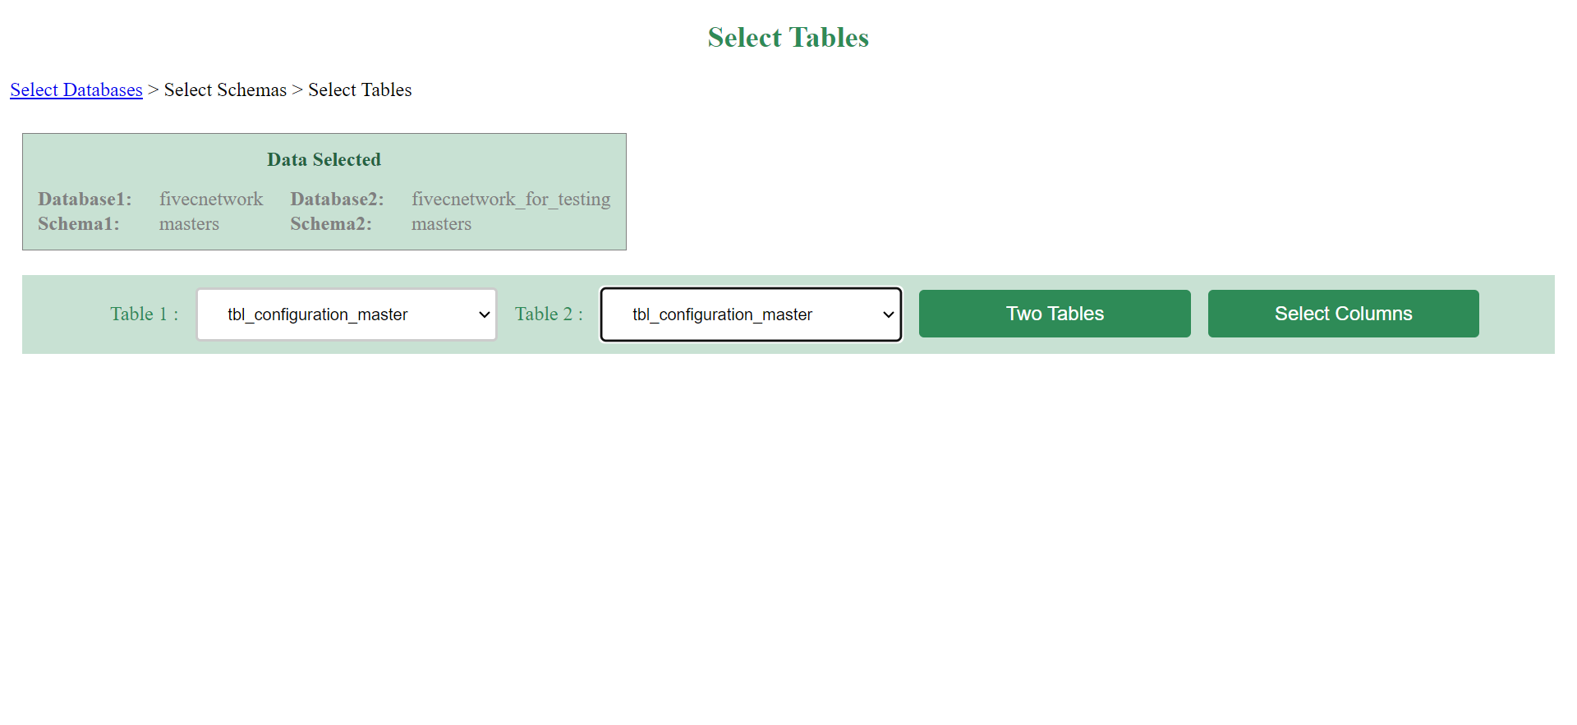

1. Select Columns and click “Two Columns”. **Ensure that the same column is selected in Column 1 and Column 2. Select only paired columns.** For example, if you want to see the paired column tcm_key, tcm_value; then either select tcm_key in Column 1 and Column 2 or select tcm_value in Column 1 and Column 2.

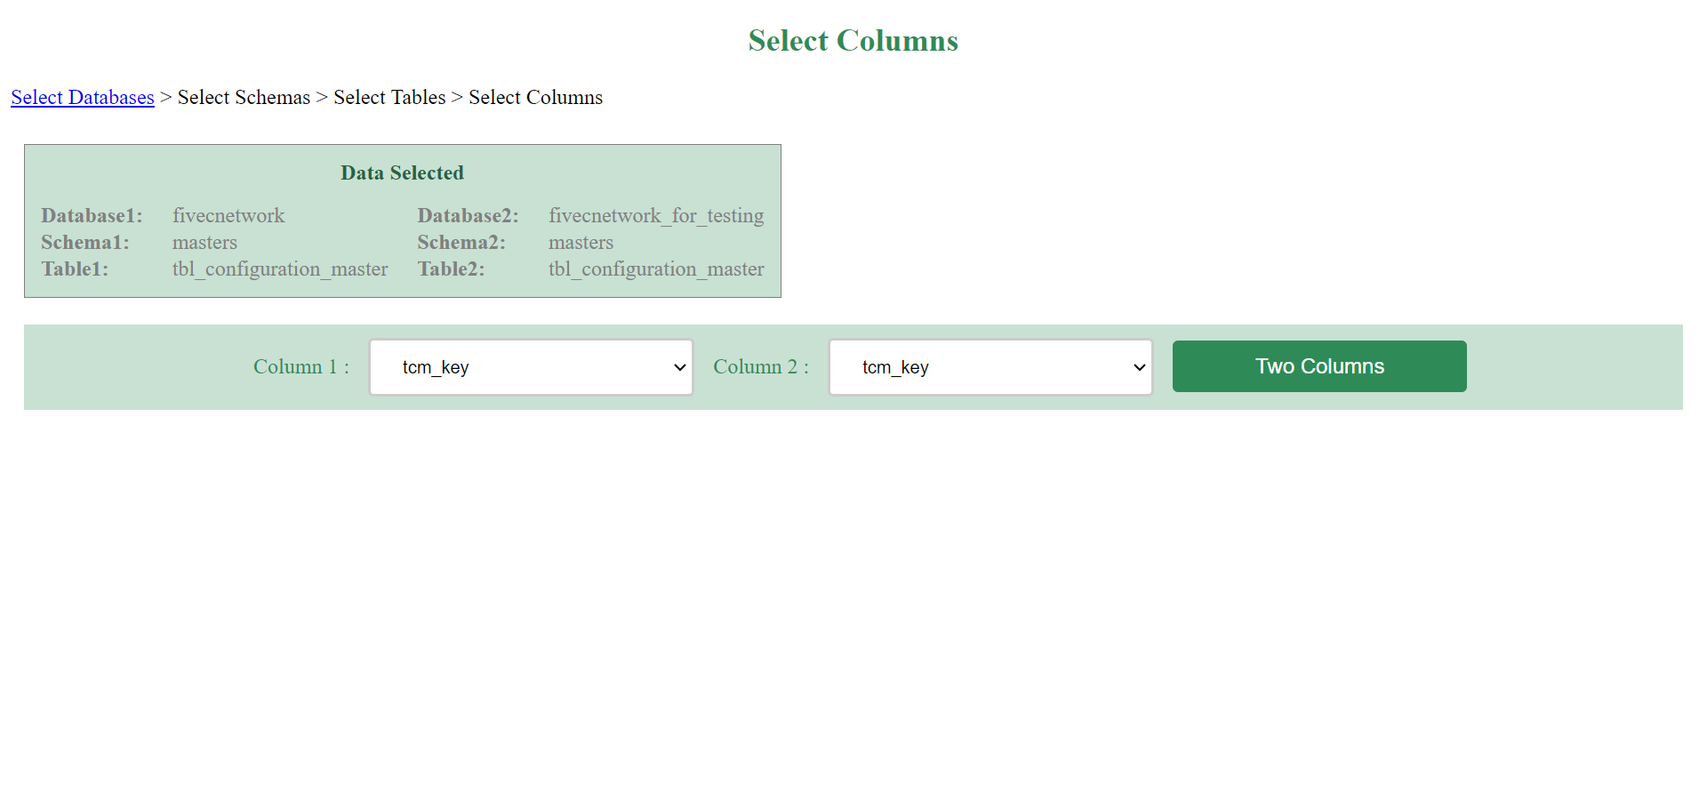

1. View the matching and non-matching paired column data. The matching happens based on the key column. For example, for the pair tcm_key and tcm_value, matching happens based on the tcm_key column but it displays both the columns.

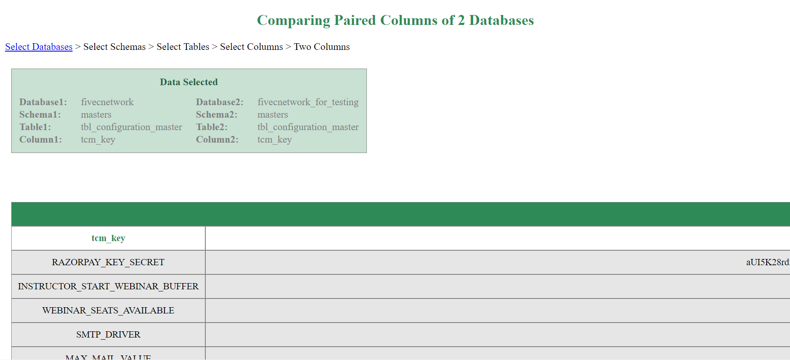

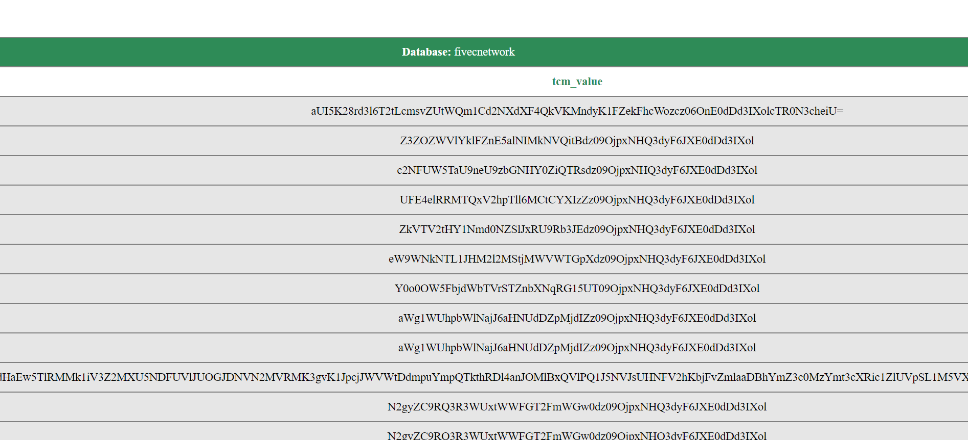

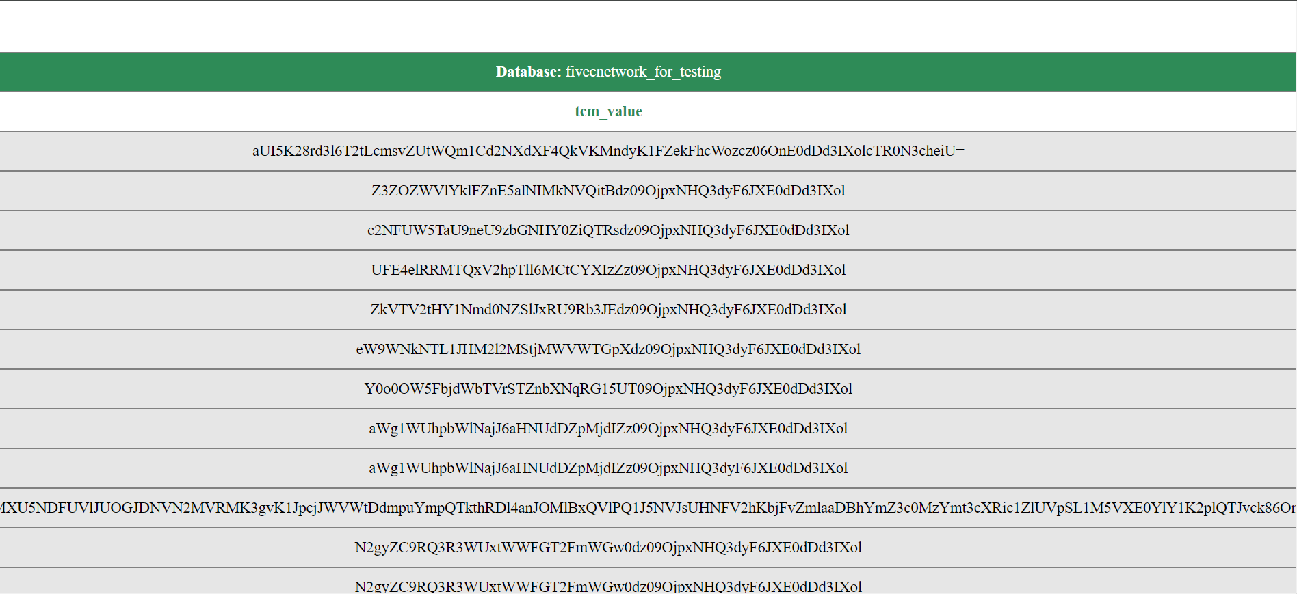

Zoomed view: With tcm_key and tcm_value from both databases.

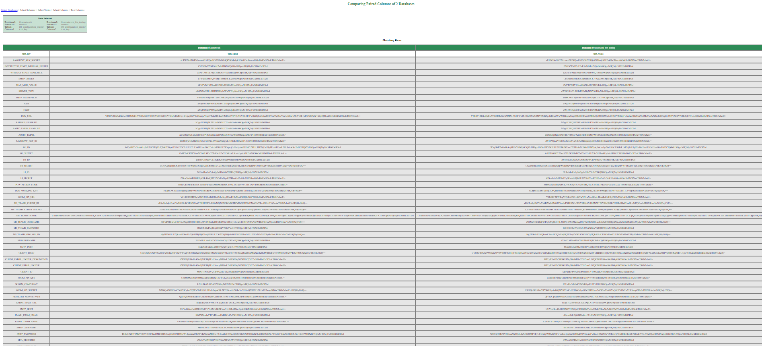

**Comparing email templates**

Email template comparison is different from other paired column comparison. If the email templates match in the two databases, then it will return “same” else it will return “different”. Here also matching happens based on the key column. In the example shown, the key column is tet_email_code. So matching tet_email_code is displayed under the “Matching Rows” table and non-matching tet_email_code is displayed under “Non-Matching Rows” table.

